**A CSP-based Rehearsal Scheduler**

**CS182 Project Proposal**

Monica Song

1. **Problem:**

[Tech week](https://en.wikipedia.org/wiki/Technical_week) in the world of dance and theater is a major headache for producers. It requires booking back-to-back rehearsals in the theater space, making the most out of the stage prior to opening night.

As tech producer for the Harvard Ballet Company, I am tasked with the responsibility of scheduling our tech week. This means accommodating the schedules of 30+ busy college students to make sure that our tech week is as efficient and effective as possible, which is quite the undertaking.

The producer has always made the tech week schedule by looking at a spreadsheet of everyone’s availability and then through a method of trial-by-error, figuring out the best time slots that work for the most people. However, you never know if the final rehearsal schedule is optimal. Inevitably, there are always dancers and musicians who simply can’t make all their scheduled rehearsal times.

An example from this year:

**Dancer’s and Choreographer’s Availabilities:**

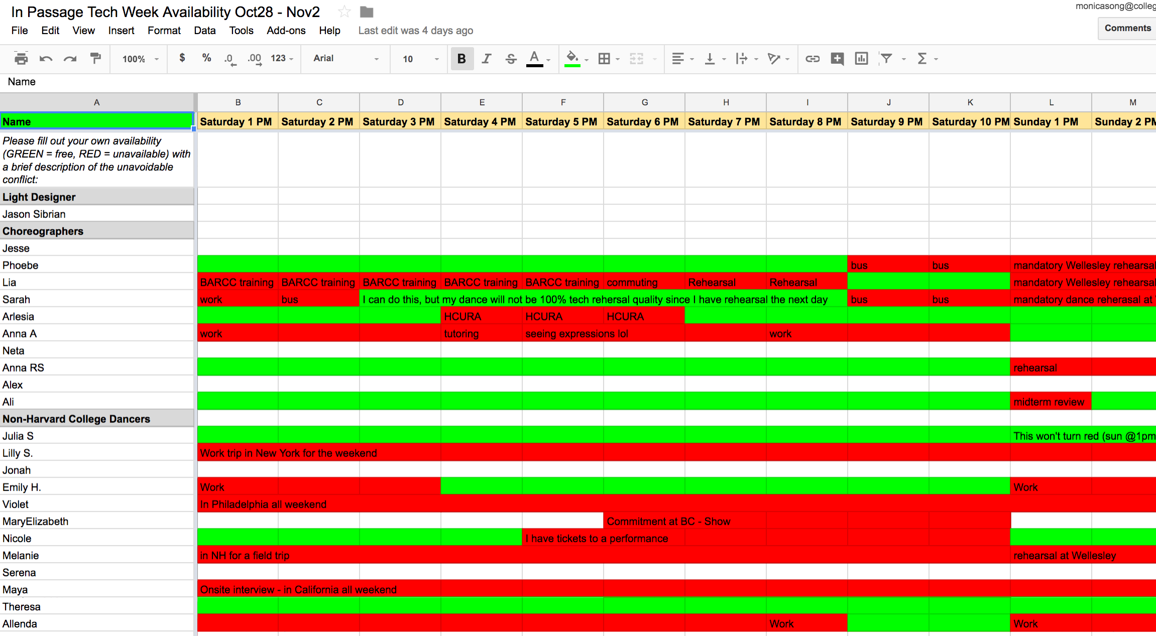

**Final Product:**

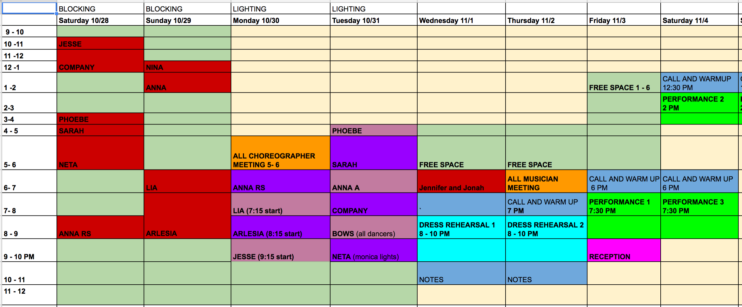

1. **Solution:**

I propose making an automated tech week rehearsal scheduler that formulates tech week scheduling as a CSP Problem:

* **Variables:** The hour-long slot of a choreographer’s rehearsal
* **Domains:** The times that the stage is open, typically 11am to 11pm
* **Constraints:**
  + Hard Constraints: Choreographer’s availability. It is necessary that a choreographer’s rehearsal be scheduled during a time which they are available.
  + Soft Constraints: The dancers in the choreographer’s piece availability. It would be most ideal if all the dancers in a choreographer’s piece could attend the rehearsal slot.
  + Nice-to-haves:
    - Non-Harvard dancers have all their rehearsals scheduled on the same day, within 3 hours of each other, so they don’t have to travel to the Harvard Campus multiple days in a row.
    - Rehearsals clustered together
    - Dinner breaks (a hour long break between 5:30 and 7:30pm)
  1. **Algorithms**: I will first implement it by using the arc-consistency algorithm AC3. Then I will try establishing K-consistency to eliminate the need to back-track. I will try implementing some local algorithms as well such as Simulated Annealing.
  2. **Expected Behavior of Resulting System:** Ideally the system is able to solve the problem in a matter of seconds. I would expect it to output schedules that satisfy all the hard constraints, but not all the soft constraints, and outperform the schedules that any human could design.

1. **Relevant Course Topics**

This problem deals directly with constraint satisfaction problems described in chapter 6 of AIMA. It will use the well known algorithms that solve CSP’s. It will also deal with some local search issues, such as simulated annealing.

1. **Focus Issues**

I think the biggest issue that I will focus on is determining how flexible my constraints are and how many variables to include in the CSP. I could potentially include the availabilities of all dancers or just the non-Harvard ones. I will also experiment with relaxing constraints. For instance, should it be a hard constraint that all dancers are available during a choreographer’s scheduled rehearsal? Furthermore, I expect to focus a lot on comparing the outputs of different algorithms and analyzing their run times.

Because my project tries to solve a problem that I have attempted several times with less than optimal results, I want to emphasize the practicality and flexibility of my solution. Though it will not be a major part of my project, I would like to implement a GUI (i.e. website) so that future Harvard Ballet Company producers and dancers will be able to use my scheduling software. As opposed to coloring in a spreadsheet, dancers should be able to simply put in their schedules similar to a Doodle Poll and the producer can simply run the scheduling software from the click of button. What used to take 3 hours of scheduling and rescheduling now only takes 5 seconds.

1. Project Resources
   1. Useful Links
      1. <http://gki.informatik.uni-freiburg.de/teaching/ws1415/csp/csp09.pdf>
      2. Chapter 6 of AIMA
   2. Papers
      1. Lorterapong P, Ussavadilokrit M. Construction Scheduling Using the Constraint Satisfaction Problem Method. Journal Of Construction Engineering & Management [serial online]. April 2013;139(4):414-422. Available from: Academic Search Premier, Ipswich, MA. Accessed October 28, 2017.
      2. Hattori H., Ito T., Ozono T., Shintani T. (2005) A Nurse Scheduling System Based on Dynamic Constraint Satisfaction Problem. In: Ali M., Esposito F. (eds) Innovations in Applied Artificial Intelligence. IEA/AIE 2005. Lecture Notes in Computer Science, vol 3533. Springer, Berlin, Heidelberg
      3. Runwei Cheng and Mitsuo Gen, "Evolution program for resource constrained project scheduling problem", International Conference on Evolutionary Computation, Orlando, Florida, USA, pp. 736-741, June 1994.
      4. Rose C, Coenen J. Comparing four metaheuristics for solving a constraint satisfaction problem for ship outfitting scheduling. International Journal Of Production Research [serial online]. October 2015;53(19):5782-5796. Available from: Business Source Complete, Ipswich, MA. Accessed October 28, 2017